**Chapter 2 - QUIZ – Basic Switch Concepts and Configuration**

1. Refer to the following command and error message to answer the question: What does the error message signify?

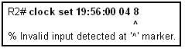

1. A parameter is missing.
2. The command was entered in the wrong CLI mode.
3. The data of one of the parameters is incorrect.
4. The command is ambiguous
5. What is the effect of entering the **banner login #Authorized Personnel Only!#** command?
6. **#Authorized Personnel Only!#** appears after the user logs in.
7. **Authorized Personnel Only!** appears only when the user makes a Telnet connection.
8. **#Authorized Personnel Only!#** appears only when the user enters global configuration mode.
9. **Authorized Personnel Only!** appears before the username and password login prompts for any connection.
10. Match each command on the left to the appropriate description on the right.

|  |  |  |  |  |
| --- | --- | --- | --- | --- |
| A. | **Switchport port-security violation restrict** | 🡺 |  | Frames with unknown source addresses are dropped and notification is sent. |
| B. | **Switchport port-security violation protect** | 🡺 |  | Frames with unknown source addresses are dropped and no notification is sent. |
| C. | **Switchport port-security violation shutdown** | 🡺 |  | Frames with unknown source address make the port err disabled and notification is sent. |
| D. | **Switchport port-security maximum** | 🡺 |  | Defines the number of MAC addresses associated with a port. |
| E. | **Switchport port-security mac-address sticky** | 🡺 |  | Allows dynamically learned MAC addresses to be stored in the running configuration. |

1. Refer to the MAC address table described here to answer the question. An Ethernet switch has developed the MAC address table described above. What action does the switch take when it receives the frame with the destination MAC address 00-00-3D-1F-11-03 and the source MAC address 00-00-3D-1F-11-01?

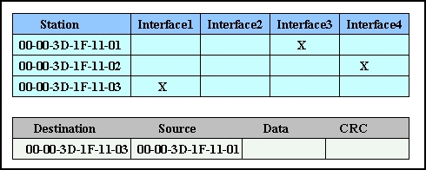

1. Forward the frame out all interfaces.
2. Forward the frame out all interfaces except Interface 3.
3. Discard the frame.
4. Forward the frame out Interface1.
5. Forward the frame out Interface2.
6. Forward the frame out Interface3.
7. Refer to the following command output to answer the question. What can be determined from the command output?

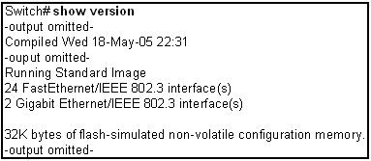

1. The system has 32 KB of NVRAM.
2. The switch has 24 physical ports.
3. The system was last restarted on May 18, 2005.
4. The Cisco IOS is a non-standard image.
5. What does pressing Ctrl P on the command line do?
6. Begins context checking.
7. Accesses symbolic translation.
8. Accesses the command history buffer.
9. Initiates command prompting.
10. What advantage does SSH offer over Telnet when remotely connecting to a device?
11. Encryption.
12. More connection lines.
13. Connection-oriented services.
14. Username and password authentication.
15. Refer to the following network topology diagram description to answer the question: How many collision and broadcast domains are presented in the network?

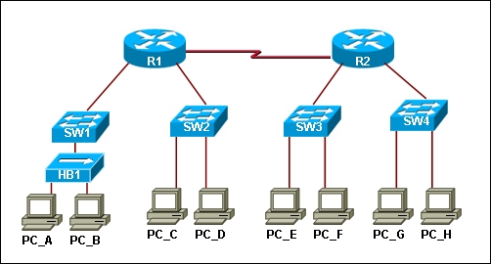

1. Eight collision domains and two broadcast domains.
2. Eight collision domains and three broadcast domains.
3. Twelve collision domains and five broadcast domains.
4. Thirteen collision domains and two broadcast domains.
5. Match the term on the left to the appropriate description on the right.

|  |  |  |  |  |
| --- | --- | --- | --- | --- |
| A. | DHCP starvation | 🡺 |  | Broadcasting requests for IP addresses with spoofed MAC addresses. |
| B. | CDP attacks | 🡺 |  | Using proprietary Cisco protocols to gain information about a switch. |
| C. | Telnet attack | 🡺 |  | Using brute force password attacks to gain access to a switch. |
| D. | MAC address flooding | 🡺 |  | The attacker fills the switch Content Addressable Memory (CAM) table with invalid MAC addresses. |

1. Which three statements are true about the Carrier Sense Multiple Access with Collision Detection (CSMA/CD) technology? (Choose three.)
2. In an Ethernet LAN domain, each station continuously listens for traffic on the medium to determine when gaps between frame transmissions occur and then sends the frame.
3. In an Ethernet LAN domain, stations may begin transmitting any time they detect that the network is quiet (that is, there is no traffic).
4. In the CSMA/CD process, priorities are assigned to particular stations, and the station with the highest priority transmits the frame on the medium.
5. If a collision occurs in an Ethernet LAN domain, transmitting stations stop transmitting and wait a random length of time before attempting to retransmit the frame.
6. If a collision occurs in an Ethernet LAN domain, only the station with the highest priority continues to transmit and the rest of the stations wait a random length of time before attempting to retransmit the frame.
7. In an Ethernet LAN domain, all stations execute a backoff algorithm based on their assigned priorities before they transmit frames on the medium.
8. How does the Ethernet switch process the incoming traffic using port-based memory buffering?
9. The frames are stored in queues that are linked to specific incoming ports.
10. The frames are stored in queues that are linked to specific outgoing ports.
11. The frames are transmitted to the outgoing port immediately.
12. The frames are stored in queues that are linked to the common memory area.
13. What are two key features of an Ethernet switch with Layer 2 capabilities? (Choose two.)
14. Full-duplex operation.
15. Broadcast and multicast traffic management.
16. Security through access lists.
17. Layer 3 routing functions.
18. Filtering based on MAC address.
19. Network address translation (NAT).
20. The network administrator wants to configure an IP address on a Cisco switch. How does the network administrator assign the IP address?
21. In privileged EXEC mode.
22. On the switch interface FastEthernet0/0.
23. On the management VLAN.
24. On the physical interface connected to the router or next-hop device.
25. Why should a default gateway be assigned to a switch?
26. To have remote connectivity to the switch via such programs as Telnet and ping.
27. To send frames through the switch to the router.
28. To pass frames generated from workstations and destined for remote networks to a higher level.
29. To access other networks from the command prompt of the switch.
30. Which two tasks does auto-negotiation in an Ethernet network accomplish? (Choose two.)
31. Sets the link speed.
32. Sets the IP address.
33. Sets link duplex mode.
34. Sets MAC address assignments on the switch port.
35. Sets the ring speed
36. What is the effect of entering the **SW1 (config-if)#** **duplex full** command on a Fast Ethernet switch port?
37. The connected device communicates in two directions, but only one direction at a time.
38. The switch port returns to its default configuration.
39. If the connected device is also set for full duplex, it participates in collision-free communication.
40. The efficiency of this configuration is typically rated at 50 to 60 percent.
41. The connected device should be configured as half duplex.
42. Which term describes the time delay of a frame sent from a source device and received on a destination device?
43. Bandwidth.
44. Latency.
45. Attenuation.
46. Time-To-Live.
47. Frame checksum.
48. .Match the commands listed on the left to the correct description on the right. Not all commands have a description.

|  |  |  |  |  |
| --- | --- | --- | --- | --- |
| A. | **copy running-config tftp** | 🡺 |  | Copy the current running configuration to a TFTP server. |
| B. | **copy running-config startup-config** | 🡺 |  | Save the current running configuration as the startup configuration. |
| C. | **copy tftp running-config** | 🡺 |  | Restore a configuration from a TFTP server to the running configuration. |
| D. | **copy startup-config running-config** | 🡺 |  | Restore the startup configuration to the running system. |
| E. | **copy tftp startup-config** | **X** |  |  |
| F. | **copy startup-config tftp** | **X** |  |  |

1. Match the commands listed on the left to the correct description on the right as required to secure access to the console port on a switch. Not all commands are used.

|  |  |  |  |  |
| --- | --- | --- | --- | --- |
| A. | **configure terminal** | 🡺 |  | Enter global configuration mode. |
| B. | **line con 0** | 🡺 |  | Enter configuration mode for the console line. |
| C. | **password cisco** | 🡺 |  | Set a password. |
| D. | **login** | 🡺 |  | Permit login. |
| E. | **enable** | **X** |  |  |
| F. | **line vty 0 4** | **X** |  |  |
| G. | **username admin password cisco** | **X** |  |  |